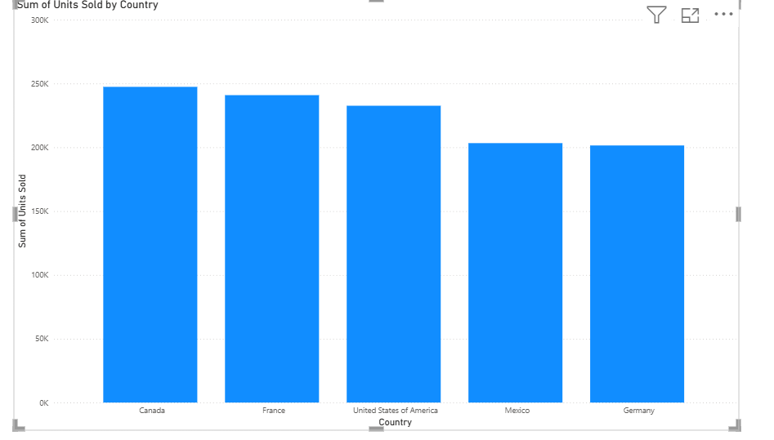

**ASSIGNMENT:1 (01-09-25)**

**COUNTRY WISE TOTAL UNIT SOLD**

**CT: STACKED COLUMN CHART**

**X-AXIS: COUNTRY**

**Y-AXIS: UNIT SOLD**

**INSIGHTS:**

1. **Germany has the lowest sales, just above 200k units.**
2. **Mexico and Germany should boost sales for the growth.**
3. **Canada leads by a slim margin compared to France and USA indicating the three markets are performing similarly.**
4. **The gap between the highest and the lowest unit is around 50k.**
5. **Germany lags behind compared to France (Two European countries).**
6. **To increase overall revenue of Germany’s sales, reallocating or campaigns need to be considered**

**ASSIGNMENT: 2 (02-09-25)**

**STEPS FOR CREATING AND FORMATTING CHARTS**

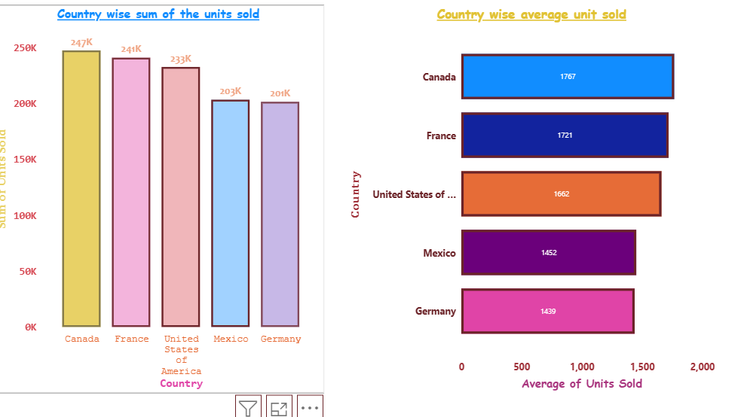

**1.Insert a stacked column chart.**

1.Go to visualization pane on the right.

2.Click on Stacked Column Chart icon.

3.Blank chart area appears on canvas.

**II. Add fields to the chart**

1. In build visual, drag categorical fields (country, product etc) to the axis area (x-axis)
2. Drag numeric field (unit sold, sales etc) to the value area (y-axis).

**III. Click Format Visual pane**

**X-axis/Y-axis**: Turn on labels, adjust fonts, size and colour.

Change colours for each category segment.

**Legend**

Use legend if needed and choose position accordingly.

**Gridlines**

* Remove the gridlines if not required by switching off.
* Turn on the Zoom slider if necessary.

According to the chart selection, pane will show Bar/Column drop down.

* Apply settings to different Bar/Column by representing in different colours.
* Choose the colour for the border and adjust the width.

**IV. GENERAL**

* Select Title Heading.
* Type appropriate text for the chart.
* Adjust the font, size and text colour.